1)

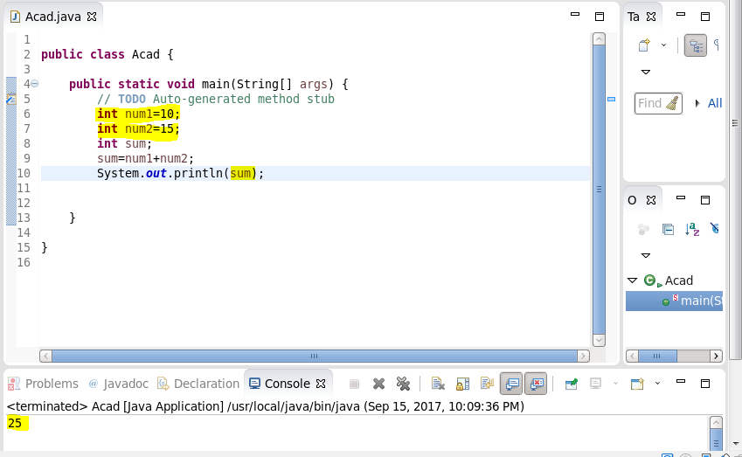

2)

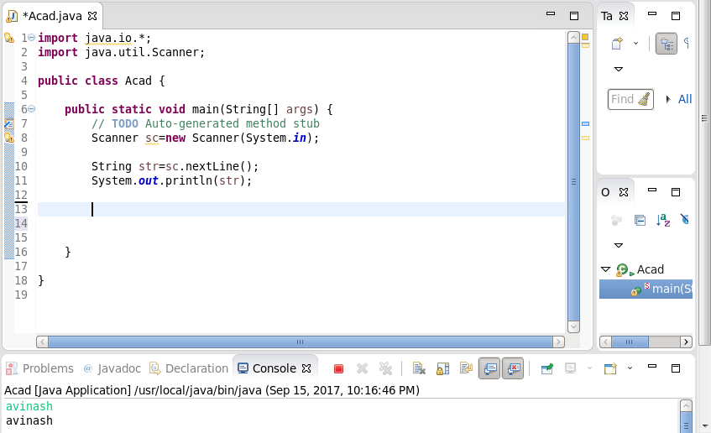

3)

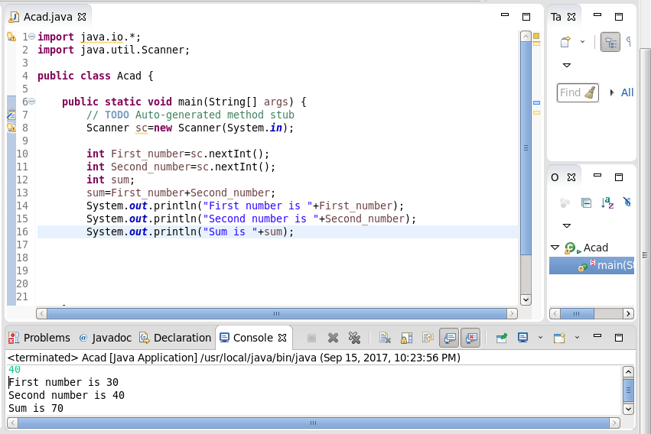

4)

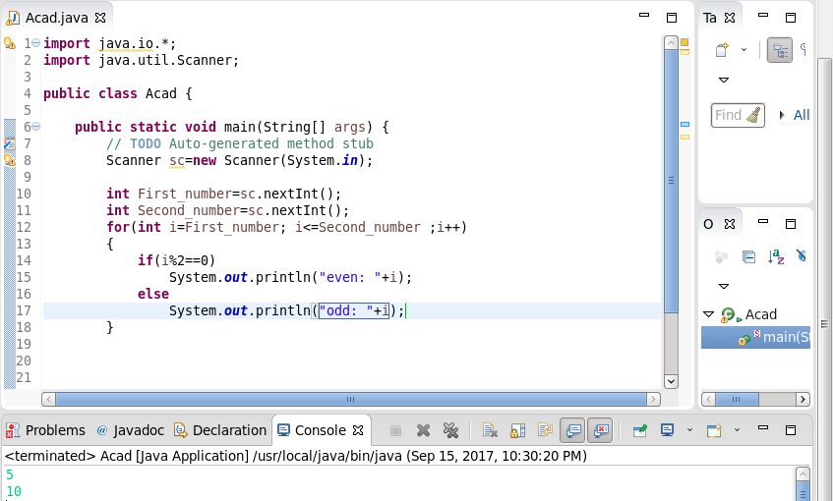

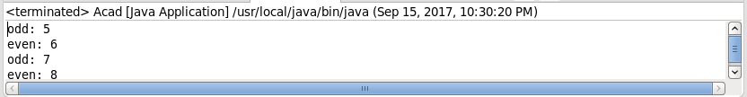



5)

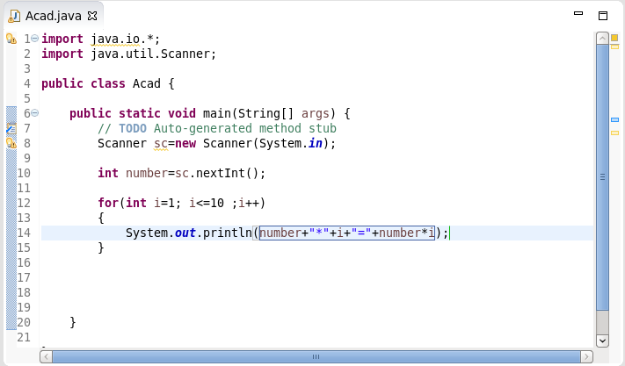

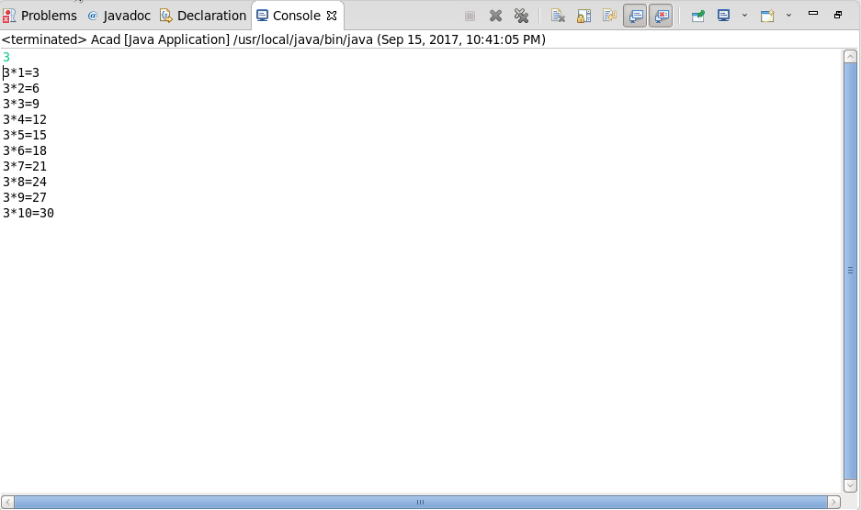

6)

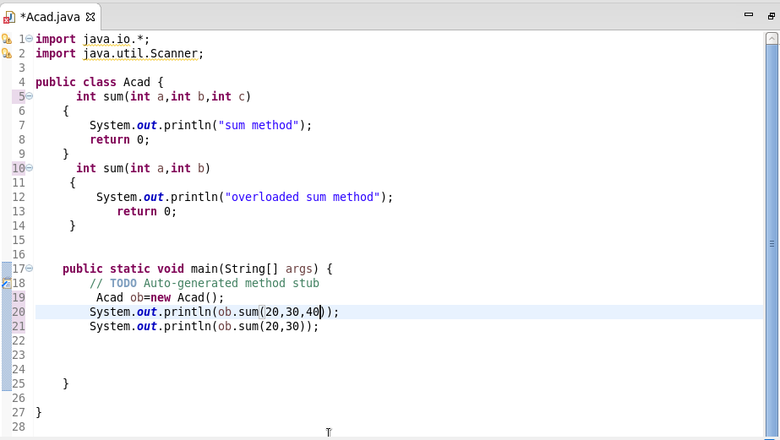

7)

We **cannot** overload by return type as it will give error:

|  |
| --- |
| public class Main  {      public int foo()  { return 10; }        // compiler error: foo() is already defined      public char foo()  { return 'a'; }        public static void main(String args[])      {      }  } |

8)

class BubbleSort

{

    void bubbleSort(int arr[])

    {

        int n = arr.length;

        for (int i = 0; i < n-1; i++)

            for (int j = 0; j < n-i-1; j++)

                if (arr[j] > arr[j+1])

                {

                    int temp = arr[j];

                    arr[j] = arr[j+1];

                    arr[j+1] = temp;

                }

    }

    /* Prints the array */

    void printArray(int arr[])

    {

        int n = arr.length;

        for (int i=0; i<n; ++i)

            System.out.print(arr[i] + " ");

        System.out.println();

    }

        public static void main(String args[])

    {

        BubbleSort ob = new BubbleSort();

        int arr[] = {64, 34, 25, 12, 22, 11, 90};

        ob.bubbleSort(arr);

        System.out.println("Sorted array");

        ob.printArray(arr);

    }

}

o/p:- 11 12 22 25 34 64 90